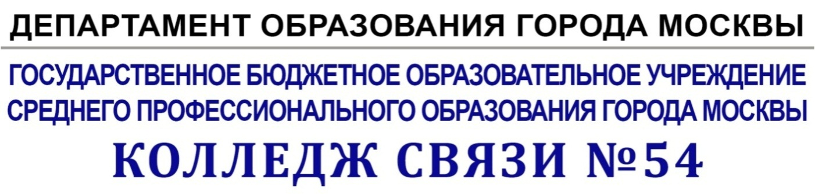

УтверждАЮ

Зам. директора по УМР

__________Бозрова И.Г.

«___»__________20__ г.

**Методические указания**

**к практическим занятиям**

**по дисциплине Иностранный язык**

Авторы – составитель

Шварцберг Н. Б.

преподаватель иностранного языка

Рассмотрено на заседании ПЦК Иностранных языков

Протокол от «_______»______________20 №______

Председатель ПЦК__________________И.М.Копылова

**Цели и задачи практической работы :**

• Оказывать методическую помощь студентам при изучении дисциплины "Английский язык" при выполнении практических работ.

• Активизировать употребление профессиональной лексики в речи студентов, связанной с конкретными специальностями.

• Обучать логичному и последовательному изложению своих мыслей в соответствии с предложенной ситуацией, максимально приближенной к реальной жизни и в пределах освоенного лексико-грамматического материала.

• Применять отработанные стилистические умения и навыки при работе с аутентичными текстами.

• Активизировать лексику по деловому языку, при работе с документацией и при оформлении деловых писем.

• Активизировать употребление в речи студентов интернациональной лексики.

• Развивать творческие способности студентов, активизировать мыслительную деятельность, повышая положительную мотивацию к изучению английского языка.

• Отрабатывать навыки работы со специальными тематическими словарями, с научными справочными пособиями, а также навыки реферирования.

• Оказывать методическую помощь при написании рефератов.

• Познакомить с использованием условных сокращений в английском языке.

**Contents**

1. **My family**
2. **My FLAT**
3. **What is a Contract?**

**Вариант1**

**My Family**

**Моясемья**

My name is Alfred. I am a businessman. I want to tell you a few words about my family. My family is rather large. I have got a mother, a father, a sister, a brother, a grandmother and a grandfather.

First of all, some words about my parents. My father’s name is John. He works for a joint-stock company as a computer programmer. My father is a very experienced employee and he likes his job.

My mother’s name is Helen. She is an economist, but she doesn’t work now. She runs the house and looks after my younger brother.

My grandparents don’t work. They are on pension.

My sister Mary is a student. She isn’t married. She has a part-time job as a secretary at the Ministry of Foreign Trade. Mary tries to combine work with her study and she does it rather well.

My little brother is six years old. He goes to the kindergarten.

We have got a lot of relatives. We are deeply attached to each other and we get on very well.

**Задание №1. Заполните пропуски глаголом tobe  в нужной форме.**

e.g. We …students. – We are students.

1.     My father…a lawyer. He…at work now.

2.     My friends…programmers, but they…not at work now.

3.     Where…my bag? It…on that chair.

4.     The documents…on the table.

5.     He…a very experienced worker.

6.     Who…responsible for this project?

7.     These…very interesting offers.

**Задание №2. Заполните пропуски данными глаголами в скобках в PresentSimple.**

e.g.  She…everyday (to work). –She works everyday.

1.     She…as a research worker (to work).

2.     They often…us (to visit).

3.     I…at the University (to study).

4.     He always…this girl on his way to the office (to meet).

5.     We…a lot of letters from Russian into English (to translate).

6.     My younger brother always…me to help him (to ask).

7.     My working day…early in the morning (to begin).

8.     They…at this factory (to work).

**Задание №3. Переведите предложения на английский язык.**

1.     –Добрый день, г-н Смирнов. Как ваши дела?

-Спасибо, хорошо.

-Рад это слышать. Кстати говоря, позвольте мне представить вам моего коллегу - г-на Петрова. Г-н Петров мой партнер по бизнесу. Он работает в моей компании.

-Добрый день, рад с вами познакомиться, г-н Смирнов.

-Взаимно.

      2. Мой отец обычно уходит на работу очень рано.

      3. Я работаю налоговым инспектором в большой компании.

      4. Мы всегда получаем письма и телеграммы от деловых партнеров.

      5. Каждое утро она переводит факсы с английского на русский.

**Задание №4. Заполните пропуски соответствующими притяжательными местоимениями.**

e.g. (She)…mother is a teacher. –Her mother is a teacher.

1. (I)…brother is at home. 2. (He)…wife is at the office. 3. (They)…telegrams are on the table. 4. (She)…father is a manager. 5. (You)…friends are auditors.

6. (We)…employees are at the office. 7. (They)…business partners are good social workers. 8. (I)…translation is very difficult. 9. (We)…office is not far from the centre. 10. (You)…offerisveryinteresting.

**Задание №5. Переведите предложения на английский язык.**

1. Моя сестра - юрист. 2. Ее муж - врач. 3. Его брат - менеджер. 4. Их коллеги -интересные люди. 5. Возьми свои письма! 6. Переведи их факсы! 7. Не читайте мои записи! 8. Их работа - очень интересная. 9. Наши бухгалтера - очень опытные работники. 10. Давайте просмотрим их документы.

**Задание №6. Переделайте предложения, используя притяжательный падеж.**

e.g. The documents of our director. –Our director’s documents.

1.     The son of this engineer.

2.     The letters of our economists.

3.     The work of a secretary.

4.     The company of our partners.

5.     The profession of this man.

6.     The duties of these women.

7.     The wife of Mr. Smith.

**Задание №7. Заполните пропуски соответствующими объектными местоимениями.**

e.g. Send…(she) these documents. –Send her these documents.

1. This is a very interesting offer. I want to discuss…(it). 2. Please, send…(he) this message. 3. We seldom visit…(they). 4. Our teacher often asks…(we) a lot of questions. 5. My friends always congratulate…(I) on my birthday. 6. Let’s invite…(she) to our office. 7. Don’t call…(I). I’m very busy this morning! 8. Shall I tell…(she) your request? 9. These letters are very important. Please, look…(they) through. 10. Don’t ask…(we) about it!

**Задание №8. Переведите предложения на английский язык.**

1.     –Простите, ваш управляющий, г-н Иванов, сегодня здесь?

-К сожалению его сегодня нет. Он плохо себя чувствует.

-Очень жаль. Я думаю, что это его документы. Отдайте их ему, пожалуйста.

-Нет, это не его документы.

-А чьи это документы?

-Это документы нашего заместителя директора.

-Понятно. Тогда отдайте ему их.

-Хорошо.

      2. –Привет, Анна. Рад снова тебя видеть. Как твои дела?

          -Так себе, а как ты?

          -Спасибо, хорошо. Кстати говоря, как дела у твоего брата?

           -У него все хорошо. У него теперь семья-жена и ребенок.

           -Я рад за него. Передавай ему привет.

      3.  - Добрый день. Извините, я опоздал

            -Добрый день, Джон. Рад снова Вас видеть. Проходите, пожалуйста. Итак, давайте продолжим наши переговоры и обсудим наш новый контракт с иностранными партнерами.

**Вариант 2**

**MY FLAT**

**Квартира**

 I live a new 16-storeyed block of flats. There's a big supermarket on the ground floor and it's very convenient to do everyday shopping.

Our flat is on the fifth floor. It's very comfortable and well-planned. We have all modern conveniences, such as central heating, electricity, gas, cold and hot running water and a telephone. There are two rooms, a kitchen, a bathroom and a hall in our flat.

Our living room is very large. In the middle of the room there is a big table and six chairs round it. Opposite the window there is a wall unit with lots of books, a TV-set and a video cassette recorder. There are two comfortable armchairs and a small coffee table in the right-hand corner. There is also a sofa and an electric fire in our living room. We like the living room best of all, because in the evenings we gather there to have tea, watch TV, talk and rest.

I have my own room. It is very cosy and light. There is a bed, a wardrobe, a desk, an armchair and several bookshelves in my room. There is a thick carpet on  the floor. The walls in my room are light-brown and there are some big posters on them. I like my room very much.

Our kitchen is large and light. It is very well-equipped. We have got a refrigerator, a microwave oven, a coffeemaker, a dishwasher and a toaster.

Задание №1. Поставьте к данным предложениям общие вопросы и ответьте на них положительно и отрицательно.

e.g. Girls are at home.     -Are girls at home?

                                        -Yes, they are.  No, they are not.

1.     Usually they have lunch at the office.

2.     He works for a well-known company.

3.     She spends much time with her family.

4.     I read English books everyday.

5.     We get letters from our business partners.

Задание №2. Поставьте к данным предложениям специальные вопросы.

e.g.   They go to the University everyday.   -Where do they go everyday?

1.     They usually do this work for their chief.

2.     They receive foreign partners every week.

3.     I often invite my friends to parties.

4.     She seldom goes out during the week.

5.     After work we sometimes go to the cinema.

Задание №3. Задайте пять альтернативных вопросов, используя текст MyFlat.

Задание №4. Дополните предложения, сделав их вопросительно-разделительными.

e.g. They work everyday, don’t they?

1.     He wants to become an engineer, …?

2.     They study at the University, …?

3.     We don’t receive business partners, …?

4.     She is at work now, …?

5.     They aren’t busy with the clients, …?

Задание №5. Заполните пропуски артиклями, где это необходимо.

1. This is… very interesting offer. 2. Are you busy at… work today? 3. My friends are at… theatre now. 4. My partner is… very reliable person. 5. We usually have our English classes in… morning. 6. He works at… large factory. 7. We often receive… letters from them. 8. There is… big round table in…middle of … room. 9. We live in…centre of …city. 10. My office is very comfortable. There is…table, …chair, …armchair and …TV-set in it.

Задание №6. Заполните пропуски необходимыми предлогами.

1. These students are…college. 2. Those programmers are…the office. 3. These journalists are…work. 4. The people are…the street. 5. These managers are…the country. 6. This engineer is…the hospital. 7. They are…the University. 8. My table is…the window. 9. He isn’t…the office now. He is …business. 10. What do you see…the picture?

Задание №7. Опишите картинки, используя конструкцию thereis/thereare.

e.g. There is a carpet on the floor.

       There are two chairs in the middle of the room.

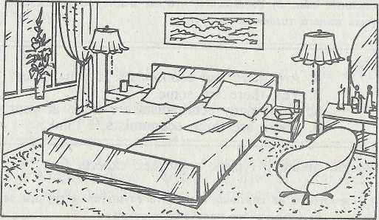

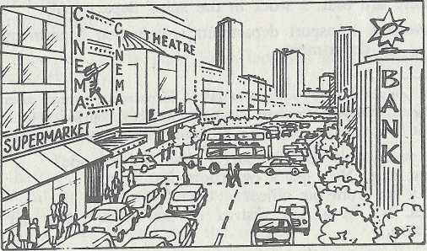

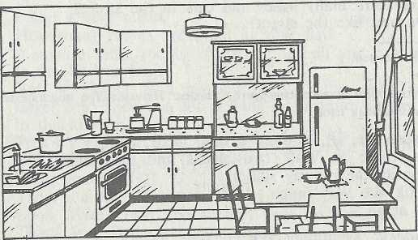

 Задание №8. Заполните пропуски неопределенными местоимениями some или any.

1. We don’t translate…articles from Russian into English. 2. You have…mistakes in your project. 3. …people always give advice. 4. We don’t have…tables in this room. 5. My colleagues don’t understand…English words. 6. Does your sister speak…foreign languages? 7. I know…lawyers from this office. 8. We don’t have…work today. 9. Do you have…modern conveniences in your flat? 10. I have…information for you.

Задание №9. Переведите предложения на английский язык.

1. Мой друг работает в этом офисе.

2. У нашего начальника двое детей.

3. Этот менеджер всегда получает письма от зарубежных партнеров.

4. Наш юрист обычно сидит за этим столом.

5. Этот программист часто обедает в офисе.

6. Куда вы обычно ходите после работы?

7. –Ваша квартира большая, не так ли?

    -Да, у меня большая и уютная квартира.

    -А где она находится?

    -Я живу в многоэтажном доме, в центре города.

    -А вам нравится ваш район?

    -Да, район действительно очень хороший.

    -Рад за вас.

8. –Извините, есть ли на этой улице какие-либо магазины?

    -Конечно, есть. На этой улице - три магазина.

    -Где они? Я их не вижу.

Вариант3

**Контракт** **What is a Contract?**

Contracts are the foundation on which business is conducted. A contract exists when two or more parties agree to exchange either property (including money) or promise of future performance. Contract is an agreement that creates a binding obligation. In general, contracts may be either oral or written. Certain classes of contracts must be written and signed. These are contracts involving the sale and transfer of real estate, and contracts to guarantee or answer for the miscarriage, debt, or default of another person. Contracts can be part of an invoice or purchase order, or they can be drafted as separate documents. Properly drafted contracts can help avoid unnecessary and costly disputes. A contract usually forms the basis of a transaction between the Buyers and the Sellers.

Essential Clauses of Contract.

Some of the items are necessary in any contract: legal title of the contracting parties, subject of the contract, quality, price, delivery, and payment terms. As a rule a contract contains a number of clauses, such as:

1.     Subject of the contract.

2.     Price, total value, and currency of the contract.

3.     Terms of Payment.

4.     Delivery.

5.     Inspection and test.

6.     Guarantee.

7.     Arbitration.

8.     Insurance and other conditions.

A sample of a contract.

CONTRACT № ___

Moscow                     200__

______________________

Hereinafter referred to as the «Sellers», on the one part, and ________________

hereinafter referred to as the «Buyers» on the other part, have concluded the present contract for the following:

**1. Subject of the Contract**

1.1. The Sellers have sold and the Buyers have bought on conditions f.o.b.________ franco-railway border_____ the following equipment: in full conformity with the technical characteristics and in complete scope of supply.

**2. Prices and Total Value**

2.1. The total value of the equipment, spare parts, tools, technical documentation and services in the volume of the present Contract amounts to______

2.2. The total amount of the Contract is….The prices are firm for the duration of the Contract, not subject to any alterations and understood to be f.o.b.

**3. Terms of Payment**

3.1. Payments at the rate of_____ per cent of the value of the delivered equipment are to be effected in ____within 30 days of the date of receipt.

**4. Delivery Dates**

4.1. The equipment specified in Clause 1 of the present contract is to be delivered complete as follows: ______

4.2. .by the time stipulated the equipment is to be manufactured in accordance with the Contract conditions, tested, packed, marked and delivered f.o.b.___

4.3. The delivery date is understood to be the date of the ‘clean-on-board’ Bill of Lading issued in the name of the Buyers, destination_____Port.

4.4. If the goods are not ready for shipment by the date of arrival of the vessel the Sellers are to cover the losses the Buyers may sustain in connection with demurrage and/or underloading of the ship.

**5. Force Majeure**

5.1. The Parties are released from partial or complete non-fulfillment of their liabilities under the present Contract, if this non-fulfillment was caused by the circumstances of Force-Majeure, namely fire, flood, provided the circumstances have directly affected the execution of the present Contract.

**6. Sanctions**

6.1. In the event of the Sellers’ delay in the supply against the dates stipulated in the Contract the Sellers are to pay to the Buyers penalty at the rate of 0,5% of the value of goods not delivered in due time for every week of the delay within the first four weeks and 1% for every subsequent week but no more than 10% of the value of the equipment not delivered in due time.

6.2. Should the delay in delivery exceed four months the Buyers shall have the right to cancel the Contract or a part thereof.

**7. Legal addresses of the Parties**

Sellers________

Buyers________

The present Contract is drawn up in the English and Russian language in 2 copies, one copy for each Party, both texts being equally valid.

The Contract enters into force on the date of its signing.

Sellers: Buyers:

Задание №1. Ответьтенаследующиевопросы, используяPresentPerfectContinuous.

1. What have you been doing since Monday? 2. What have you been doing since morning? 3. How long have you been studying English? 3. How long have you been living in Moscow? 4. How long have you been dreaming of a new job?

 5. How long have you been thinking of going abroad? 6. How long has it been raining?

Задание №2. Поставьте вопросы к следующим предложениям.

1. This secretary has been working at our office for three years. 2. My friends have been traveling in the East for three weeks. 3. My colleagues have been discussing this matter for three days. 4. My uncle has been writing his new book since 2003. 5. This play has been running at the theatre since Tuesday.

Задание №3. Переведите предложения на английский язык.

1.-Президент у себя?

  -Нет, у него переговоры с делегацией из Лондона. Они приехали в 10 часов и с тех пор обсуждают новый контракт на поставку товаров в Россию.

  -Позвоните мне, как только он освободится. Мне нужно показать ему последние данные по продажам нашего оборудования.

2. –Вы давно торгуете с этой фирмой?

    -Да, уже два года. За последнее время мы подписали два новых контракта с ними, так как мы заинтересованы в покупке товара такого ассортимента. Собственно говоря, сейчас мы ведем переговоры относительно новой партии. Если они снизят цены, мы разместим еще один заказ.

Задание №4. Поставьте вопросы к следующим предложениям.

1. By the end of the year this secretary had been working at our office for eleven months. 2. My colleagues had been discussing that matter for three hours by the time our chief arrived. 3. I had been talking to our business partners for a week by the time my boss came from abroad. 4. By the beginning of March this writer had been writing his novel for two years. 5. We had been playing golf for two hours when our colleagues joined us.

Задание №5. Заполнитепропускиглаголами, даннымивскобках, вформеPresent Continuous, Present Perfect, Present Perfect Continuous.

1. Why you…(to stare) at me like that? – I…(to look) at you for half an hour but I can’t remember where we….(to meet) before. 2. You…(to forget) this poem yet? –I…(to learn) it by heart for an hour but I…(to learn) it yet. 3. Why don’t you object to this solution? –We…(to discuss) the matter for a week, but there is no reason in any solution. 4. He…(to translate) this article so far. –He …(to translate) it since afternoon, but there are too many new words in it. 5. You…(not to wait) for your friend’s call any more? –I…(to wait) for it since morning but there is no hope that he will phone today. 6. How long you…(to look forward) to meeting your friend? –I…(to look forward) to meeting him for half a year but he ….(to return) from Ireland yet. 7. Why you…(to joke) all the time today? –I am in a good humour. Besides, I…(to joke) for a long time. 8. You still…(to lie) in the sun? –Of course, I am. I…(to lie) in the sun since last summer and  I….(to burn) my skin yet.

9. You…(to pack) your luggage yet? –I…(to pack) it for two hours, but my brother…(to bother) me all the time, so I…(to pack) it yet. 10. Are you ready to leave for the party? –No, my sister…(to dress) for two hours, and she …(to do) her hair yet.

Задание №6. Раскройтескобки, употребляяглаголывPresent Indefinite, Present Continuous, Past Indefinite, Past Continuous, Present Perfect, Present Perfect Continuous.

I…(to live) in London for a long time but still…(not to know) many of the streets in my district. The other day I…(to go) out late at a time when the fog…(to grow) thicker, and so I soon…(to lose) my way. After…(to walk) for a while, I …(to see) the friendly light of a pub, so I…(to go) in and…(to find) several friends who also…(to give) up the attempt to discover where they were. We…(to sit) down and…(to chat) for a while and we just…(to go) to leave when John…(to come) in and announced that the fog…(to become) so thick that all traffic…(to stop) over a wide area. This sometimes…(to happen) in London and it…(to mean) great inconvenience to thousands of people. I…(to remember) once meeting a friend of mine, who…(to wear) a very tired expression. “What…(to happen) to you?” I asked. “Last night I…(to leave) the office late and started to motor home, about four miles only. I…(not to go) far when I was lost, so I drew up and …(to decide) to wait for the fog to lift. It …(not to do). I had to spend the whole night in me car so now I…(to feel) very weary.” I …(to hear) of this sort of thing happening to other motorists. Personally, I never…(to go) out at night in foggy weather in my car, I…(prefer) to travel by tube then, as in the last few years we..(to have) relatively few tube breakdowns in foggy weather, although the buses…(to stop) of course in such weather.

Задание №7. Переведите предложения на английский язык.

1. Вопрос не будет рассматриваться, если документы не будут готовы.

2. Если контракт  будет подписан завтра, наши специалисты поедут в командировку за границу. 3. Как только товар прибудет, мы свяжемся с вами. 4. Документы не будут выданы до тех пор, пока главный инженер не подпишет их. 5. Вчера мы решили, что этот пункт будет включен в контракт, если обе договаривающиеся стороны согласятся на это. 6. После того как цены будут пересмотрены мы сможем разместить большой заказ.